

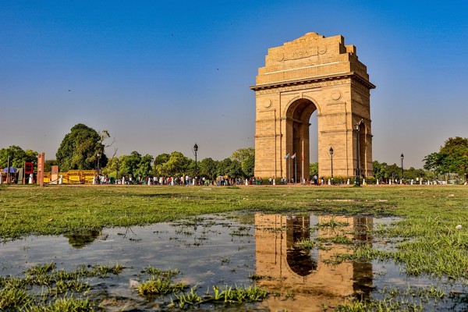

**Day 4: Journey to the Capital City - Delhi**

Travel: Agra to Delhi | Distance: 200 km | Time: 4 hours   
After breakfast, embark on our journey to Delhi! Upon arrival, check in to our hotel, then let’s explore historical sites. Afternoon visit to India Gate and Humayun’s Tomb, absorbing the capital's essence. Evening free for shopping at Connaught Place, leaving some time for reflection.  
  
---